**Assignment -2**

Python Programming

|  |  |
| --- | --- |
| Assignment Date | 24 September 2022 |
| Student Name | Charu sri J |
| Student Roll Number | 2019504512 |
| Maximum Marks | 2 Marks |

**Question:**

Build a Python code, assume you get temperature and humidity values (generated with random function to a variable) and write a condition to continuously detect alarm in case of high temperature.

**Solution:**

import random

import time

i=0

while(i<5):

temp = random.randrange(0,75)

mois = random.randrange(0,120)

print(temp," ",mois,"%")

if(temp > 50):

print("High Temperature")

elif(temp < 10):

print("Low Temperature")

if(mois > 80):

print("Very Humid Weather")

elif(mois < 20):

print("Very Dry Weather")

i+=1

time.sleep(2)

**Code:**

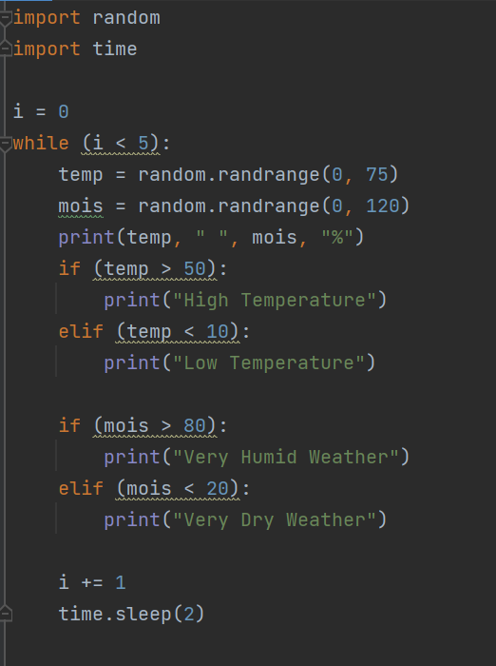

**Code Result:**

